CoProcManager
Computer\HKEY_LOCAL_MACHINE\SOFTWARE\NVIDIA Corporation\Global\CoProcManager
Satisfying solution:
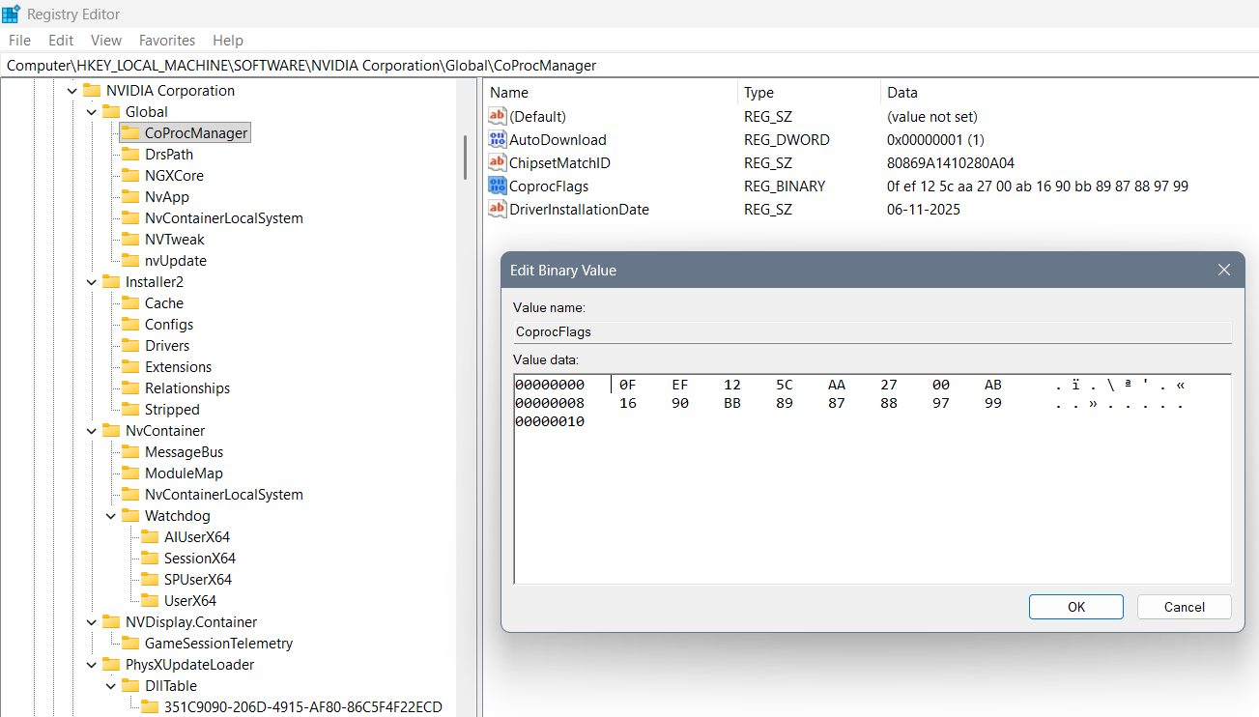
Where we used “0F” for the beginning of the code, “EF” for 3 values that are coming, “AA”, “AB” as their separators of better and worse option… In between “EF” and “AA” is a “125C” or 4700GHz the maximum speed of the processor. In between the “AA” and “AB” we can find the 2700 the middle speed of the processor… In between the “AB” and “BB” we can find the lowest boundary of the processor “1690” representing 1690GHz… In the end we used “BB” for the beginning of the coding of the processor – how it should work… The last code represents the changing value as in percentage of the usage of the processor when the need for work is there: 89 87 88 97 99…

Previously not well created settings:
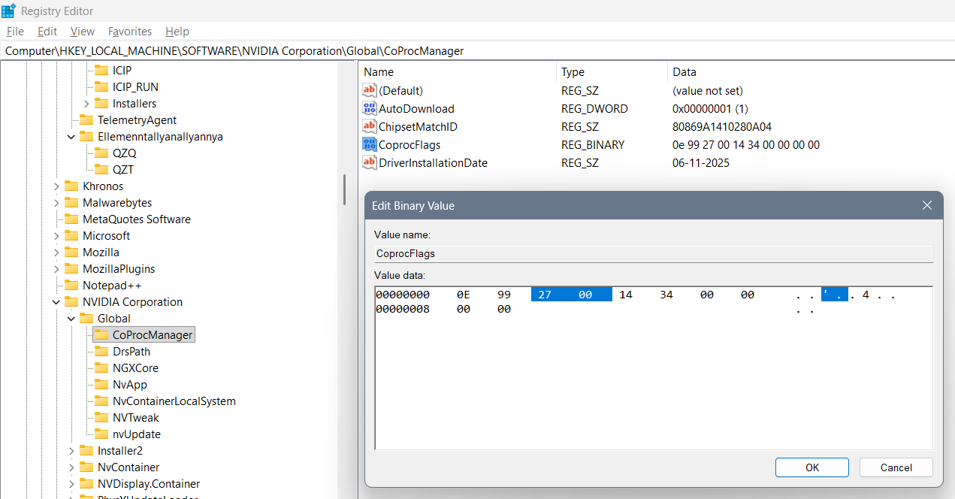
First successful edit of those commands is:
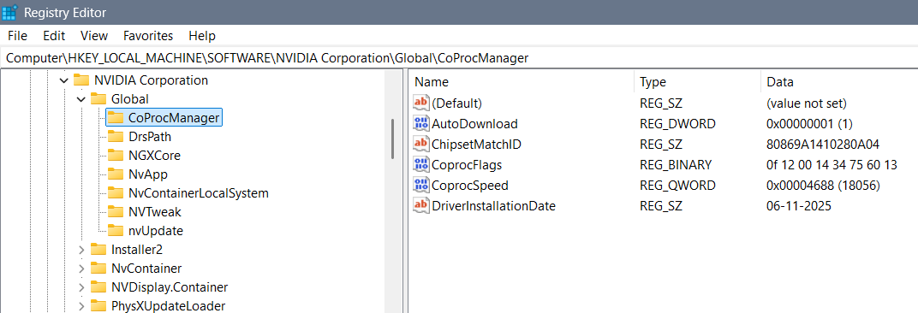
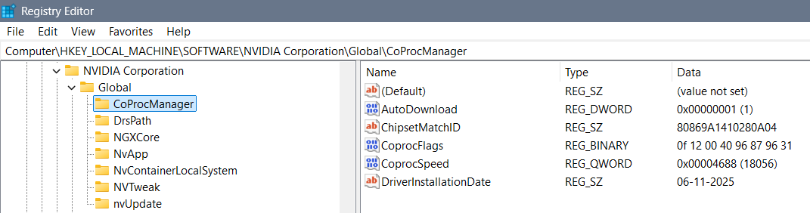
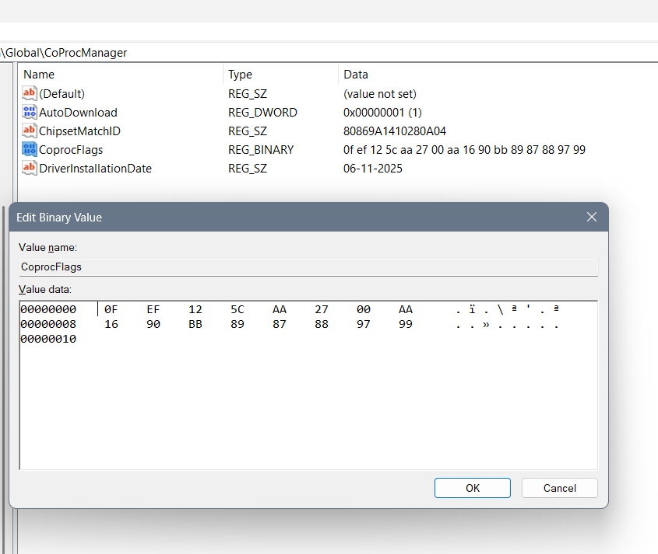
Wrong solutions
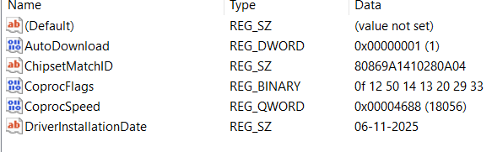

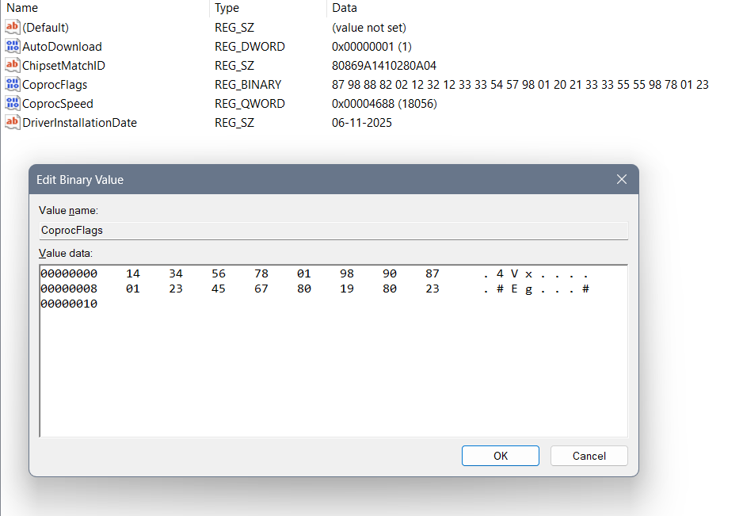

NVIDIA Control Panel 3D settings
Open:
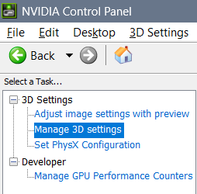
And select the next options for the purpose of 3D display to come to life thanks to the dual graphics out there:
